***What is Raspberry Pi?***

The Raspberry Pi is a mini computer that was specifically created to make tech learning easier. It has a lot of components for computer-based projects, like USB ports, an Ethernet port, an SD card slot, Wi-Fi antenna ports, and more.

It does not come with peripherals, like cables, a keyboard, a mouse, or a monitor. It is great for learning program languages, like Python, Scratch, and Wolfram. Most Raspberry Pi enthusiasts like making single-process builds to show off their do-it-yourself talents.

|  |  |
| --- | --- |
| *Chipset* |  |
| Chip | Broadcom BCM2837 |
| Processor | Quad Core Cortex A53 |
| Frequency | 1.2 GHz |
| Architecture | 64bit |
| Storage | Micro SD card |
| Memory | 1 GB RAM |
| Audio | HDMI port supports multichannel audio output |
|  | Audio line out/3.5mm headphone jack (analog) |
| Camera | CSI camera port |
| Display | DSI display port |
| Communications | Wifi 802.11n IEEE 802.11a/g/b/n compatible |
|  | Bluetooth 4.1 |
|  | Ethernet 10/100 Base-T (RJ-45 connector) |
| Operating Systems | Official supported OS are NOOBS  Raspbian |
|  | Third party OS are |
|  | Ubuntu Mate Windows IOT Core RISC |

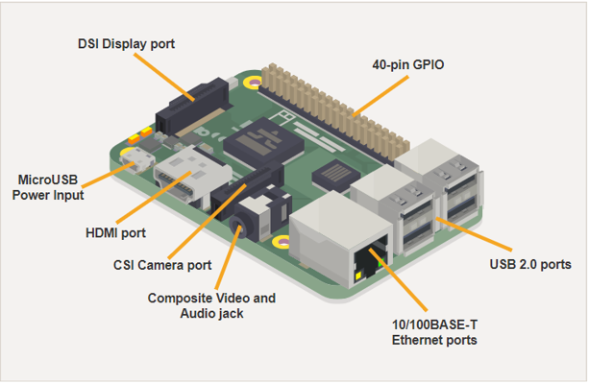

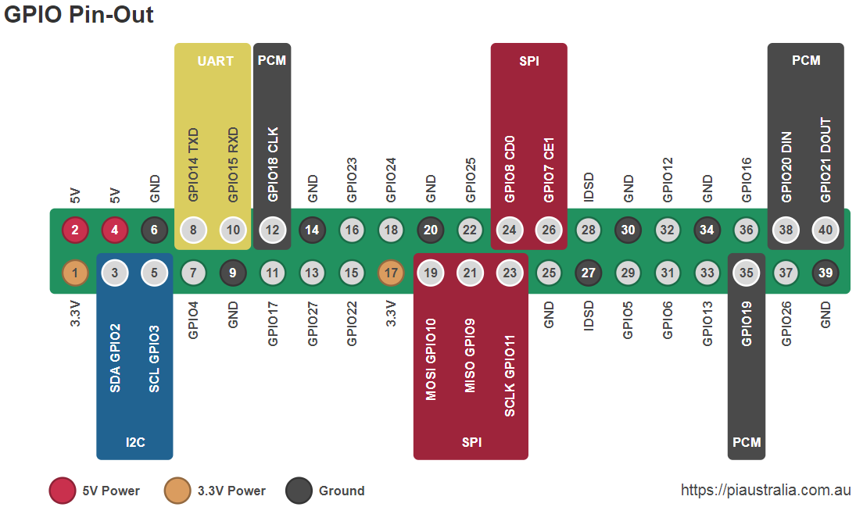

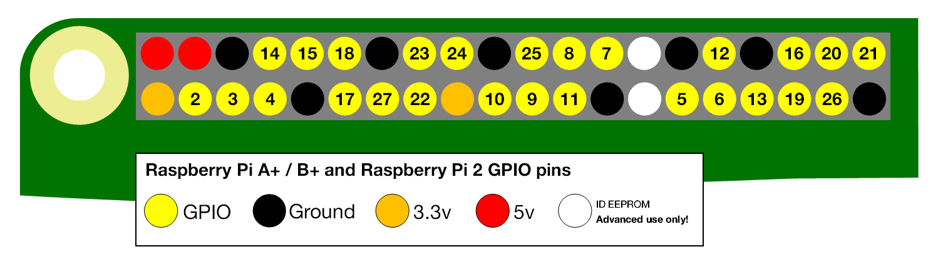

***Hardware Specifications***

**Broadcom BCM2837**

This is the Broadcom chip used in the Raspberry Pi 3, and in later models of the Raspberry Pi 2. The BCM2837 is identical to the BCM2836, only significant difference is the replacement of the ARMv7 Quad-core cluster with a Quad-core ARM Cortex A53 (ARMv8) cluster.

The ARM cores run at 1.2GHz, making the device about 50% faster than the Raspberry Pi 2. The VideoCore IV runs at 400MHz.

**BOOT Modes**

The Raspberry Pi has a number of different stages of booting.

* Bootflow – Boot sequence description
* SD card – SD card boot description
* USB – USB boot description
  + Device boot – Booting as a mass storage
  + Host boot – Booting as a USB Host
  + Mass storage boot – Boot from Mass storage Device(MSD)
  + Network boot – Boot from Ethernet

**Power Supply**

The Raspberry Pi 3 is powered by a +5.1V micro USB supply. (Exactly how much current (mA) the Raspberry Pi requires in dependent on what you connect to it. We have found that purchasing a 2.5A power supply).

Typically the model B uses between 700 – 1000 mA depending on what peripherals are connected. The maximum power the Raspberry Pi use is 1 Amp. If you need to connect a USB device that will take the power requirements above 1 Amp, then you must connect it to an externally powered hub.

The GPIO pins can draw 50mA safely, distributed across all the pins, an individual GPIO pin can safely draw 16mA. The HDMI port uses 50mA, the camera module requires 250mA, and keyboards and mice can take as little as 100mA or over 1000mA.

**Note:** Check the power rating of the devices you plan to connect to the Pi and purchase a power supply accordingly.

**Backpowering**

Backpowering occurs when USB hubs do not provide a diode to stop the hub from powering against the host computer. Other hubs will provide as much power as you want out each port. Please also be aware that some hubs will backfeed the Raspberry Pi. This means that the hubs will power the Raspberry Pi through its USB cable input cable, without the need for a separate micro-USB power cable, and bypass the voltage protection. If you are using a hub that backfeeds to the Raspberry Pi and the hub experiences a power surge, your Raspberry Pi could potentially be damaged.

**USB**

The Raspberry Pi Model B is equipped with two USB2.0 ports. These are connected to the LAN9512 combo hub/Ethernet chip IC3, which is itself a USB device connected to the single upstream USB port on BCM2835.

On the Model A, the single USB2.0 port is directly wired to BCM2835.

The USB ports enable the attachment of peripherals such as keyboards, mice, webcams that provide the Pi with additional functionality.

There are some differences between the USB hardware on the Raspberry Pi and the USB hardware on desktop computers or laptop/tablet devices.

The USB host port inside the Pi is an On-The-Go (OTG) host as the application processor powering the Pi, BCM2835, was originally intended to be used in the mobile market: i.e. as the single USB port on a phone for connection to a PC, or to a single device. In essence, the OTG hardware is simpler than the equivalent hardware on a PC.

OTG in general supports communication to all types of USB device, but to provide an adequate level of functionality for most of the USB devices that one might plug into a Pi, the system software has to do more work.

**GPIO**

This page expands on the technical features of the GPIO pins available on BCM2835 in general. For usage examples, see [GPIO usage](https://www.raspberrypi.org/documentation/usage/gpio/README.md). When reading this page, reference should be made to the BCM2835 ARM peripherals [data sheet](https://www.raspberrypi.org/documentation/hardware/raspberrypi/bcm2835/README.md), section 6.

GPIO pins can be configured as either general-purpose input, general-purpose output, or as one of up to six special alternate settings, the functions of which are pin-dependent. There are three GPIO banks on BCM2835.

Each of the three banks has its own VDD input pin. On Raspberry Pi, all GPIO banks are supplied from 3.3V. **Connection of a GPIO to a voltage higher than 3.3V will likely destroy the GPIO block within the SoC.** A selection of pins from Bank 0 is available on the P1 header on Raspberry Pi.

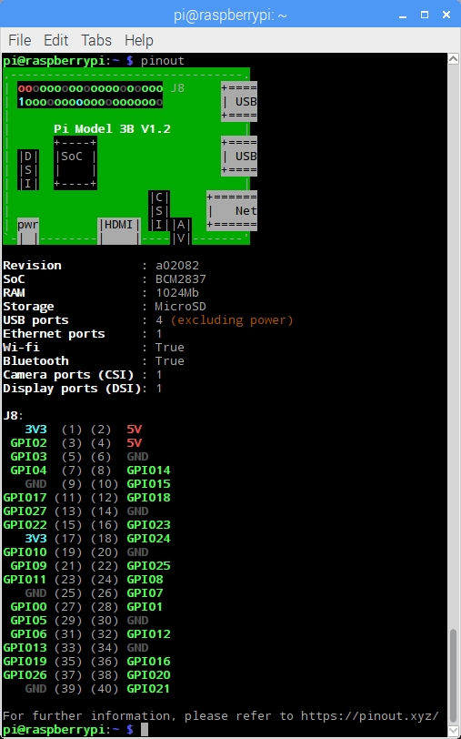

**SPI**

The Raspberry Pi is equipped with one [SPI](https://en.wikipedia.org/wiki/Serial_Peripheral_Interface_Bus) bus that has 2 chip selects.

The SPI master driver is disabled by default on Raspbian. To enable it, use [raspi-config](https://www.raspberrypi.org/documentation/configuration/raspi-config.md), or ensure the line dtparam=spi=on isn't commented out in /boot/config.txt, and reboot. If the SPI driver was loaded, you should see the device /dev/spidev0.0.

The SPI bus is available on the P1 Header:

MOSI P1-19

MISO P1-21

SCLK P1-23 P1-24 CE0

GND P1-25 P1-26 CE1

**DPI (Parallel Display Interface)**

An up-to-24-bit parallel RGB interface is available on all Raspberry Pi boards with the 40 way header (A+, B+, Pi2, Pi3, Zero) and Compute Module. This interface allows parallel RGB displays to be attached to the Raspberry Pi GPIO either in RGB24 (8 bits for red, green and blue) or RGB666 (6 bits per colour) or RGB565 (5 bits red, 6 green, and 5 blue).

This interface is controlled by the GPU firmware and can be programmed by a user via special config.txt parameters and by enabling the correct Linux Device Tree overlay.

**CSI camera**

The Raspberry Pi has a *Mobile Industry Processor Interface* (MIPI) *Camera Serial Interface*Type 2 (CSI-2), which facilitates the connection of a small camera to the main Broadcom BCM2835 processor. This is a camera port providing an electrical bus connection between the two devices.

The purpose of this interface was to standardize the attachment of cameras modules to processors for the mobile phone industry. The CSI-2 version of the interface was extremely popular and used on almost all the mobile phones and devices currently found. With increasing camera resolution, the bandwidth of data transferring from the camera to the processor also increases. The CSI-2 specification developed by the MIPI Alliance solves a number of problems that arise when large amounts of data require transfer to the processor.

MIPI CSI-2 version 1.01 supports up to four data lanes, where each lane has a maximum of 1 Gbps bandwidth, to provide a total bandwidth of 4 Gbps. In addition, the interface uses the least number of electrical connections to reduce PCB complexity. The data communication is one-way, from camera to processor.

***Requirement Specifications***

The Raspberry Pi ships as just the single-board minicomputer. There are a few additional components you will need before you can get started.

* **Raspberry Pi —** There are six different models of Raspberry Pi. The [Pi 2 Model B](http://target.georiot.com/Proxy.ashx?TSID=15093&dtb=1&GR_URL=http%3A%2F%2Fwww.amazon.com%2FRaspberry-Pi-Model-Project-Board%2Fdp%2FB00T2U7R7I%3Fm2k%3Dd_im%26m1k%3Dd_im%26tag%3Dimoreb-20%26ascsubtag%3DUUimUdUnU36244YYwYg)or [Pi 1 Model B+](http://target.georiot.com/Proxy.ashx?TSID=15093&dtb=1&GR_URL=http%3A%2F%2Fwww.amazon.com%2FRaspberry-Pi-Model-512MB-Computer%2Fdp%2FB00LPESRUK%3Fm2k%3Dd_im%26m1k%3Dd_im%26tag%3Dimoreb-20%26ascsubtag%3DUUimUdUnU36244YYwYg) and [Pi 3 Model B](http://target.georiot.com/Proxy.ashx?TSID=15093&dtb=1&GR_URL=https%3A%2F%2Fwww.amazon.com%2FRaspberry-Pi-RASPBERRYPI3-MODB-1GB-Model-Motherboard%2Fdp%2FB01CD5VC92%3Ftag%3Dimoreb-20%26ascsubtag%3DUUimUdUnU36244YYwYg) are ideal for beginner projects because they are the most versatile and have the widest range of capabilities. The Pi 3 Model B has the added bonus of having a quad-core processor and 1 GB of RAM so it supports heavier operating systems, like Ubuntu and Microsoft 10. The [Model A+](http://target.georiot.com/Proxy.ashx?TSID=15093&dtb=1&GR_URL=https%3A%2F%2Fwww.amazon.com%2FRaspberry-Pi-Model-A-256MB%2Fdp%2FB00PEX05TO%3Ftag%3Dimoreb-20%26ascsubtag%3DUUimUdUnU36244YYwYg)is a powerful board for building robotics, but doesn't have an Ethernet port and only comes with one USB port. So, it's better for people that are a little more savvy with engineering technology. Raspberry Pi Zero is basically a miniature version of the Model A+, but has a more robust computing power. It has a micro USB port and mini HDMI port for 1080p output compatibility but doesn't have wireless capability. It only costs $5 and Adafruit [sells v.1.3 for just $5](https://www.adafruit.com/product/2885?gclid=CjwKCAiAjanRBRByEiwAKGyjZWtZ07fdRZkZ8bQZ7Zdv5JzshDlRM3LWvAlkEo0k84SY_ugfQJfAAhoC5ZgQAvD_BwE), but you can only buy one per order. The Raspberry Pi Zero W is the same single-board computer as the standard Zero but *does* support wireless and Bluetooth connectivity. It [costs $10 on Adafruit](https://www.adafruit.com/product/3400), but you can only order one per day.
* **Power supply —** You will need a 5V micro-USB power supply. You can find them for really cheap online. You may even have one from a non-apple mobile device lying around the house. I recommend the [CanaKit 5V power supply](http://target.georiot.com/Proxy.ashx?TSID=15093&dtb=1&GR_URL=http%3A%2F%2Fwww.amazon.com%2FCanaKit-Raspberry-Supply-Adapter-Charger%2Fdp%2FB00MARDJZ4%2Fref%3Dpd_bxgy_147_3%3Fie%3DUTF8%26refRID%3D1KN61YDVBAH1C9HZ2SBW%26m2k%3Dd_im%26m1k%3Dd_im%26tag%3Dimoreb-20%26ascsubtag%3DUUimUdUnU36244YYwYg" \o ").
* **USB keyboard**
* **USB mouse —** If you prefer to use a Bluetooth keyboard and mouse, you could just get a Bluetooth adapter. I have a [Kinivo BTD-400](http://target.georiot.com/Proxy.ashx?TSID=15093&dtb=1&GR_URL=http%3A%2F%2Fwww.amazon.com%2FKinivo-Btd-400-Bluetooth-4-0-USB%2Fdp%2FB007Q45EF4%2F%3Fm2k%3Dd_im%26m1k%3Dd_im%26tag%3Dimoreb-20%26ascsubtag%3DUUimUdUnU36244YYwYg" \o "), but there are dozens of different brands out there.
* **Micro SD card —** The microSD card must have at least 8 GB of storage. You can purchase one that comes pre-loaded with Raspberry Pi's New Out of Box Software (NOOBS), but you can also [download the software for free](https://www.raspberrypi.org/downloads) from the website, so there is no need to purchase a special NOOBS microSD card.
* **Micro SD USB card reader —** You will need something that you can connect the microSD card to your PC or Mac in order to download software onto it. [Adafruit carries one](https://www.adafruit.com/products/939?gclid=Cj0KEQiArou2BRDcoN_c6NDI3oMBEiQANeix5p-yLKsS-R4g6SUBe5pwvpkIMbXIJutBmUccQ3x6tLEaAuwG8P8HAQ) that is perfect for Raspberry Pi, but you can pick one up at just about any electronics or office supply store.
* **A monitor or TV that supports HDMI or composite video —** You can use an older composite video display, but HDMI works better and supports audio transfers.
* **An HDMI cable or composite video cable**, depending on what the screen you use supports
* **An ethernet cable (or Wi-Fi dongle) —** A connection to the Internet is not required for setup, but many Raspberry Pi projects use them.

***Steps to use Raspberry pi***

There are five basic steps need to be followed.

1. **Reformat micro SD card**

* The first step to getting started with Raspberry Pi is to reformat the microSD card that you will use to download the operating system. Even brand new SD cards will have some extraneous files on them. Reformatting it will remove all files and completely clear the card.
* Insert your microSD card into the USB card reader.
* Connect the card reader to your computer.
* Download SD Formatter 5.0.
* Double-click on SDFormatter_5.00B.pkg in your /downloads folder in your Dockto install SD Formatter 5.0.
* Follow the instructions in the installation window.
* Click the Launchpad icon in your Dock. It looks like a silver rocket ship.
* Find the SD Formatter 5.0 app.
* To move between Launchpad windows, click the Next Page icons at the bottom center of the screen, or swipe to the right or left with your trackpad or Magic Mouse.
* Click on the SD Formatter 5.0 app to open it. A formatting window will appear on your desktop.
* Under Select Card select your microSD card from the dropdown menu.
* Click Format in the bottom right corner.

When the reformat is complete, you will get a notification window. Select **OK** to close the window.

1. **Download NOOBS onto the Micro SD card**

* The next step is to get NOOBS onto the microSD card. Once it's loaded, you can plug it into your Raspberry Pi and configure the operating system. The microSD card should already be connected to your computer at this time.
* Download the ZIP file of [NOOBS Version 2.4.5](https://www.raspberrypi.org/downloads/noobs/). It is a large file and will take a while to complete. You will want Raspbian, so do not download NOOBS Lite.
* Double-click on the NOOBS file from the **Downloads folder** in your **Dock** to open it.
* Select the first file inside the NOOBS folder.
* Scroll down and Shift + left-click on the last file in the NOOBS folder.
* Drag and drop all selected NOOBS files into the SD card icon on your desktop. You don't have to open the SD card drive.
* Right-click on the SD card icon.
* Select "Eject [SD Card Name]".
* Remove the card reader from your computer.
* Remove the microSD card from the card reader.

1. **Setup your Raspberry Pi**

* Insert the microSD card into the card slot on the underside of the Raspberry Pi.
* Plug the USB keyboard into one of the USB ports.
* Plug the USB mouse into one of the USB ports

Alternatively, connect the **Bluetooth adapter** into one of the USB ports.

* Turn on your **monitor or TV set** and make sure it is set to the proper input (e.g. HDMI 1 or Component)
* Plug the **HDMI or video component cable** into the monitor or TV set.
* Connect the other end of the cable into the Raspberry Pi.
* Connect an ethernet cable to your router if you plan to connect to the Internet.
* Connect the other end of the cable to your Raspberry Pi.

Alternately, connect the **Wi-Fi adapter** to the Raspberry Pi.

* Connect the power supply to the Raspberry Pi.
* Plug the power supply into the power outlet. This will turn on and boot up Raspberry Pi. A power indicator light will begin to glow, letting you know that you are connected,

1. **Download Raspbian operating system on the Raspberry Pi**

Beginners should start off using the Raspbian operating system. It is the easiest to use and there are hundreds of projects out there that use the Raspbian operating system. If you want to use a different operating system later on, you can reconfigure your Raspberry Pi then.

Once you have successfully followed the steps above, a start screen will appear on your monitor or TV.

* Select Raspbian.
* Click Install.
* When the warning window pops up. Click Yes to confirm. This is just letting you know that the microSD card will be overwritten with an uncompressed version of the Raspbian operating system.
* Wait for the installation process to complete.

Once the installation process is finished, Raspbian will automatically begin to boot.

1. **Configure Raspberry Pi**

When Raspbian begins to load a bunch of lines of code will appear. This will continue until the boot process has completed. Then, the Raspbian Home screen will appear. You will need to configure your Raspberry Pi system in order to add your location, date, and time.

* Click Menu in the upper left corner of the screen.
* Select **Preferences** in the dropdown menu.
* Select **Raspberry Pi Configuration** under Preferences.
* When the configuration window appears, click on the Localisation tab.
* Click on Set Locale… to set your location.
* Click on Set timezone… to set your local time.
* Click on Set Keyboard… to set your keyboard language.
* Reconfiguring your Raspberry Pi will require a reboot. When the reboot window appears, click **Yes** to continue.

[You are set up and ready to start using Raspberry Pi. The mini computing world is your oyster. The only question now is, what project will you build?](https://www.imore.com/sites/imore.com/files/styles/xlarge/public/field/image/2016/02/Raspberry-Pi-connect-HDMI-hero.jpg?itok=vuBfzxxO" \o "Connecting the HDMI cable to Raspberry Pi)

***Difference between B and B+***



* 4 USB ports – for the first time, you’ll be able to have a keyboard, mouse and wifi dongle plugged in without needing a powered hub. Bear in mind, you will probably need a more powerful power supply for the B+ if you want to use all 4 ports. They’re recommending a 2A supply. Of course, if you’re just using a mouse and a keyboard then a 1A supply will probably be absolutely fine.
* Better USB hot plug capability – you should be able to plug in your wifi dongles in without reboots!
* A new Ethernet port with activity lights.
* The yellow composite video port has gone and there is now a combined 3.5mm jack that provides audio and the analogue video signal.
* The micro USB power socket has changed sides. This means that all the ports are on the same side of the Pi – so cable management is much better with the B+.
* The B+ sports a 40-pin GPIO header (compared to the B’s 26) and no longer has a P5 and P3 header. All the GPIO is on that one header now. The 26 pins to the left (nearest the corner) are backwards compatible so all your add-on boards will work (with the exception of any audio boards like the Wolfson which requires the P5 header which is, of course, not on the B+).
* 4 mounting holes, conveniently located on the corners of the board rather than the 2 oddly-placed holes on the B.
* On the back, the B+ uses a micro SD card (as opposed to the B’s full size SD card) with a push-push action (i.e. you push it in and it locks in place, you push it again and it clicks out). The card still protrudes slightly (presumably to make it easy to remove) but the (metal) slot is a vast improvement on the flimsy plastic of the B.
* Lower power requirements – it will use between 0.5 watts and 1 watt less than the model B.
* Much better audio output thanks to a dedicated power supply.

**Reference links**

<https://www.imore.com/how-get-started-using-raspberry-pi>

https://www.raspberrypi.org/documentation/hardware/raspberrypi/README.md

**Install Raspbian on Raspberry pi’s SD card**

https://maker.pro/raspberry-pi/tutorial/how-to-install-raspbian-on-your-raspberry-pi-sd-card

**Difference between Wifi extensions**

<http://homenetworkadmin.com/wireless-b-vs-g-vs-n-vs-ac-difference/>

<https://www.semiconductorstore.com/blog/2014/WiFi-standards-802-11a-b-g-n-vs-802-11ac-Which-is-Best/806>

**Linux Boot process**

<https://www.thegeekstuff.com/2011/02/linux-boot-process>